# Task-4

# Name: JayamNagatulasi

# USN:1NT20IS066

# Construct an App for illustrating the Explicit Intent usage in Android

XML CODE:

<?xml version="1.0" encoding="utf-8"?>

<LinearLayout xmlns:android="<http://schemas.android.com/apk/res/android>" xmlns:app="<http://schemas.android.com/apk/res-auto>" xmlns:tools="<http://schemas.android.com/tools>" android:layout_width="match_parent"

android:layout_height="match_parent" android:background="#ccffee" tools:context=".MainActivity" android:orientation="vertical" android:gravity="center">

<EditText android:id="@+id/name"

android:layout_width="match_parent" android:layout_height="wrap_content" android:hint="Enter your name" />

<Button android:id="@+id/click"

android:layout_width="match_parent" android:layout_height="wrap_content" android:text="CLICK" />

</LinearLayout>

Activity.java :

ackage com.example.is180_explicit;

import androidx.appcompat.app.AppCompatActivity; import android.content.Intent;

import android.os.Bundle; import android.view.View; import android.widget.Button; import android.widget.EditText;

public class MainActivity extends AppCompatActivity { @Override

protected void onCreate(Bundle savedInstanceState) {

super.onCreate(savedInstanceState); setContentView(R.layout.*activity_main*); EditText name ;

Button click ;

name = findViewById(R.id.*name*) ; click = findViewById(R.id.*click*);

click.setOnClickListener(new View.OnClickListener() { @Override

public void onClick(View v) {

Intent intent = new Intent(MainActivity.this, activity2.class); Bundle b = new Bundle() ; b.putString("name",name.getText().toString()); intent.putExtras(b) ;

startActivity(intent);

}

});

}

}

<?xml version="1.0" encoding="utf-8"?>

<LinearLayout xmlns:android="<http://schemas.android.com/apk/res/android>" xmlns:app="<http://schemas.android.com/apk/res-auto>" xmlns:tools="<http://schemas.android.com/tools>" android:layout_width="match_parent" android:layout_height="match_parent"

tools:context=".activity2" android:gravity="center">

<TextView android:layout_width="match_parent" android:layout_height="wrap_content" android:id="@+id/mytext" android:text="NAME COMES HERE" android:textSize="40dp" android:textAlignment="center"

/>

</LinearLayout>

package com.example.is180_explicit;

import androidx.appcompat.app.AppCompatActivity; import android.os.Bundle;

import android.widget.TextView;

public class activity2 extends AppCompatActivity { @Override

protected void onCreate(Bundle savedInstanceState) {

super.onCreate(savedInstanceState); setContentView(R.layout.*activity_2*); TextView myName ;

String nameFromFirstActivity =" "; myName = findViewById(R.id.*mytext*) ;

nameFromFirstActivity = getIntent().getStringExtra("name"); myName.setText(nameFromFirstActivity);

}

}

# Output:

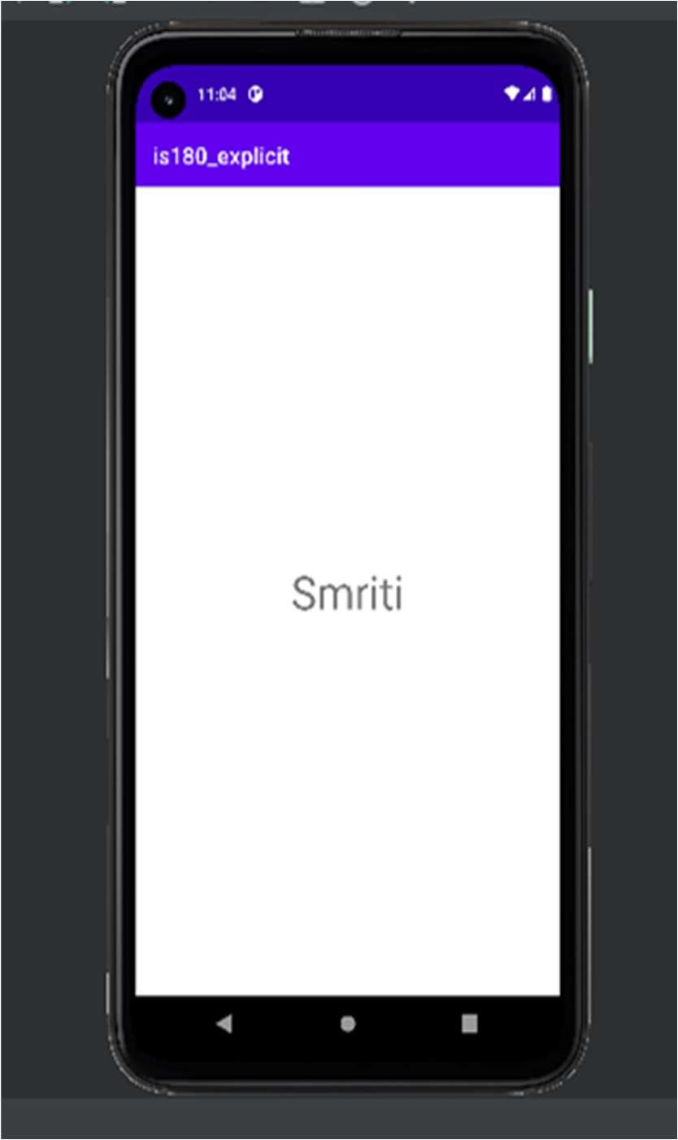

1. Construct an App for illustrating the Implicit Intent usage in Android XML Code:

<?xml version="1.0" encoding="utf-8"?>

<LinearLayout xmlns:android="<http://schemas.android.com/apk/res/android>" xmlns:app="<http://schemas.android.com/apk/res-auto>" xmlns:tools="<http://schemas.android.com/tools>" android:layout_width="match_parent" android:layout_height="match_parent" tools:context=".MainActivity"

android:orientation="vertical" android:gravity="center" android:background="#ccd9ff">

<TextView android:layout_width="match_parent" android:layout_height="wrap_content" android:id="@+id/myphone" android:hint="Enter the Phone Number" android:layout_margin="20dp"

/>

<Button android:layout_width="match_parent" android:layout_height="wrap_content" android:id="@+id/call" android:text="CALL" android:layout_margin="20dp"/>

</LinearLayout>

# Main_Java Code:

package com.example.external;

import androidx.appcompat.app.AppCompatActivity; import android.annotation.SuppressLint;

import android.content.Intent; import android.net.Uri; import android.os.Bundle; import android.view.View; import android.widget.Button;

import android.widget.EditText;

public class MainActivity extends AppCompatActivity { EditText phoneNumberToCall ;

Button call ; @Override

protected void onCreate(Bundle savedInstanceState) { super.onCreate(savedInstanceState); setContentView(R.layout.*activity_main*);

call = findViewById(R.id.*call*) ;

phoneNumberToCall = findViewById(R.id.*myphone*) ;

call.setOnClickListener(new View.OnClickListener() { @Override

public void onClick(View v) {

Uri myUri = Uri.*parse*("tel:"+phoneNumberToCall.getText().toString()); Intent it = new Intent(Intent.*ACTION_DIAL*, myUri) ;

startActivity(it);

}

});

}

}

Output:

